
LABORATORY MANUAL
for
CS8581 : NETWORKS LABORATORY
of
B.E (CSE)
(Anna University Regulation 2017) For the Batch 2019 - 2023

Semester : V
Academic Year : 2021-2022
DEPARTMENT OF COMPUTER SCIENCE AND ENGINEERING
KCG COLLEGE OF TECHNOLOGY,

CHENNAI – 600 097

Date of Release : Approved by (HOD)

Copy No: 1 of 2 Copy Holder HOD

CERTIFICATE

This is to certify that ------------------------------------------------------, roll number/
register number ( ) of third year (V Semester) B.E CSE has successfully completed all the lab exercises in CS8581 – NETWORKS LABORATORY for the academic year 2021-2022 in the Odd Semester.

Faculty In-Charge HoD VISION OF THE COLLEGE

KCG College of Technology aspires to become a globally recognized centre of excellence for science, technology & engineering education, committed to quality teaching, learning, and research while ensuring for every student a unique educational experience which will promote leadership, job creation, social commitment and service to nation building

MISSION OF THE COLLEGE

- Disseminate knowledge in a rigorous and intellectually stimulating environment
- Facilitate socially responsive research, innovation and entrepreneurship
- Foster holistic development and professional competency
- Nurture the virtue of service and an ethical value system in the young minds

VISION OF THE DEPARTMENT
The Department of Computer Science and Engineering desires to become a: prominent centre of excellence for producing competent IT professionals for providing software and software enabled solutions

MISSION OF THE DEPARTMENT
- Provide quality education in the field of computer science and engineering related domains.
- Facilitate socially responsive research and innovation.
- Inculcate professional behavior, a spirit of entrepreneurship and commitment to the progress of the nation.
- Accommodate evolving software development tools and required implementation facilities.

PROGRAMME EDUCATIONAL OBJECTIVES
The graduates of B.E COMPUTER SCIENCE & ENGINEERING will

PEO 1 | Acquire a strong foundation in basic and advanced engineering concepts, students are expertised in formulating, analyzing and solving engineering problems.
PEO 2 | Be enhancing the logical reasoning skills, students are made capable to design optimized Technological solutions in industry and academics as well.
PEO 3 | Be encouraging continuous self-learning ability, students are trained to meet the current demands of industry, carrying out research in cutting edge technologies

PROGRAMME OUTCOMES AND PROGRAMME SPECIFIC OUTCOMES
After successful completion of B.E COMPUTER SCIENCE& ENGINEERING Programme, the
students will be able to
PO No. | Description of the PO
PO 1 | Apply the knowledge of mathematics, science, engineering fundamentals, and an engineering specialization to the solution of complex engineering problems.
PO 2 | Identify, formulate, review research literature, and analyze complex engineering problems reachi substantiated conclusions using first principles of mathematics, natural sciences, and engineerin sciences
PO 3 | Design solution for complex engineering problems and design systems components or process that meet the specified needs with appropriate consideration for the public health and safety , and the cultural, societal, and environmental considerations.
PO 4 | Use research- based knowledge and research methods including design of experiments, analysis and interpretation of data, and synthesis of the information to provide valid conclusions.
PO 5 | Create, select, and apply appropriate techniques, resources, and modern engineering and IT tool including prediction and modeling to complex engineering activities with an understanding of th limitations.
PO 6 | Apply reasoning informed by the contextual knowledge to assess societal, health, safety, legal an cultural issues and the consequent responsibilities relevant to the professional engineering practice.
PO 7 | Understand the impact of the professional engineering solutions in societal and environmental contexts and demonstrate the knowledge of, and need for sustainable development.
PO 8 | Apply ethical principles and commit to professional ethics and responsibilities and norms of th engineering practice.
PO 9 | Function effectively as an individual, and as a member or leader in diverse teams, and i multidisciplinary settings
PO 10 | Communicate effectively on complex engineering activities with the engineering community and with society at large, such as , being able to comprehend and write effective reports and design documentation, make effective presentations, and give and receive clear instructions.
PO 11 | Demonstrate knowledge and understanding of the engineering and management principles and apply these to one’s own work , as a member and leader in a team, to manage projects and in multidisciplinary environments.
PO 12 | Recognize the need for, and have the preparation and ability to engage in independent and lifelong learning in the broadest context of technological change.
n

PSO No. | Description of PSO
PSO 1 | Relate the rudiments of mathematics, science and engineering knowledge to classify, formulate, plan and explore compound engineering problems of electric circuits, analog and digital electronic circuits, process control and instrumentation field along with computational skills.
PSO 2 | Relate and apply suitable techniques for designing engineering hardware and software tools to assist in design, implement & evaluate the control, measurement, process and instrumentation systems to engross for a life- long learning and thereby work effectually as an distinct individual and also in a multi-disciplinary team.
PSO 3 | Comprehend the influence of Professional performance and ethics, communicate commendably with Electronics and Instrumentation engineering community and establish a better environment for the society with continual growth.

COURSE OUTCOMES
Upon completion of this course, the student will be able to:

CO No | Description of the Course Outcome | Blooms level
CO 1 | Experiment with protocols using TCP . | K3
CO 2 | Experiment with protocols using UCP . | K3
CO 3 | Compare the performance of different transport layer protocols. | K2
CO 4 | Use simulation tools to analyze the performance of various network protocols. | K3
CO 5 | Analyze various routing algorithms. | K4
CO 6 | Implement error correction codes. | K4

CS8581 : NETWORKS LABORATORY
Amendment Sheet
Doc Ref. (or Expt No.) | Page No | Details of the Revisions | Effective date of the revision | Approved by

CS8581 : NETWORKS LABORATORY INDEX
Expt. No. | Name of the Experiment | Page No | Date | Signature
1 | Study of basic network commands
2a | Simulating ping command
2b | Simulating traceroute command
3 | Create a socket for http for web page upload and download
4a | Applications using TCP sockets like echo client and echo server
4b | Applications using TCP sockets like chat
4c | Applications using TCP sockets like file transfer
5 | Applications using TCP and UDP sockets like DNS
6 | Simulating ARP / RARP protocols
7a | Study of Network Simulator (NS2)
7b | Study of TCP/UDP performance using Simulation tool
8a | Implementation of distance vector routing protocol
8b | Implementation of Link state routing protocol
9 | Performance evaluation of Routing protocols using Simulation tool.
10 | Simulation of congestion control and flooding.
11 | Implementation of error detection technique-cyclic redundancy check
 | Content beyond syllabus
12 | Applications using TCP and UDP sockets  like SNMP
13 | Implementation of subnetting
14 | Construct a Star Topology
15 | Construct a Ring Topology
16 | Case study- LAN environment in Lab

EX NO: 1
DATE: STUDY OF BASIC NETWORK COMMANDS
1.0 AIM
Learn to use commands like tcpdump, netstat, ifconfig, nslookup and traceroute.
tcpdump
2.0 DESCRIPTION
Tcpdump prints out a description of the contents of packets on a network interface that match the boolean expression; the description is preceded by a time stamp, printed, by default, as hours, minutes, seconds, and fractions of a second since midnight.
It can also be run with the -w flag, which causes it to save the packet data to a file for later analysis, and/or with the -r flag, which causes it to read from a saved packet file rather than to read packets from a network interface (please note tcpdump is protected via an enforcing apparmor(7) profile in Ubuntu which limits the files tcpdump may access).
It can also be run with the -V flag, which causes it to read a list of saved packet files. In all cases, only packets that match expression will be processed by tcp dump.
3.0 PROGRAM
Input:tcpdump -n Output:
tcpdump: verbose output suppressed, use -v or -vv for full protocol decode listening on eth0, link-type EN10MB (Ethernet), capture size 65535 bytes 16:15:05.051896 IP blog.ssh > 10.0.3.1.32855: Flags [P.], seq 2546456553:2546456749, ack 1824683693, win 355, options [nop,nop,TS val 620879437 ecr 620879348], length 196
Writing to a file
# tcpdump -w /path/to/file
# tcpdump -w /var/tmp/tcpdata.pcap
tcpdump: listening on eth0, link-type EN10MB (Ethernet), capture size 65535 bytes 1 packet captured
2 packets received by filter
0 packets dropped by kernel
Reading from a file # tcpdump -r /path/to/file
tcpdump: verbose output suppressed, use -v or -vv for full protocol decode listening on eth0, link-type EN10MB (Ethernet), capture size 65535 bytes 16:15:05.051896 IP blog.ssh > 10.0.3.1.32855: Flags [P.], seq 2546456553:2546456749, ack
1824683693, win 355, options [nop,nop,TS val 620879437 ecr 620879348], length 196
Specifying the number of packets to capture
# tcpdump -c 10
# tcpdump host google.com
tcpdump: verbose output suppressed, use -v or -vv for full protocol decode listening on eth0, link-type EN10MB (Ethernet), capture size 65535 bytes ^C
0 packets captured
4 packets received by filter 0 packets dropped by kernel
Netstat:
Description :
Netstat prints information about the Linux networking subsystem. The type of information printed is controlled by the first argument, as follows:
By default, netstat displays a list of open sockets. If you don't specify any address families, then the active sockets of all configured address families will be printed.
Input : netstat -a | more
Output: To show both listening and non-listening sockets.
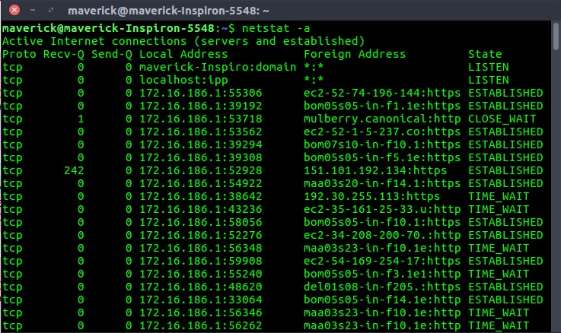

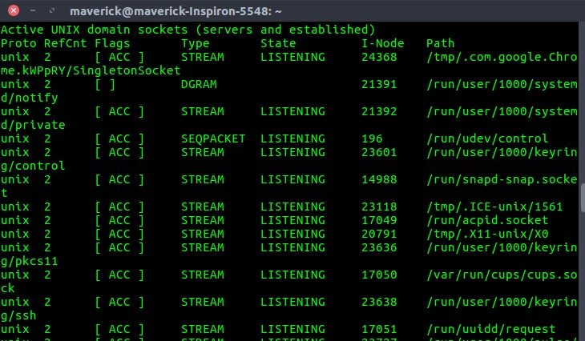

Input : netstat -at
Output: To list all tcp ports.
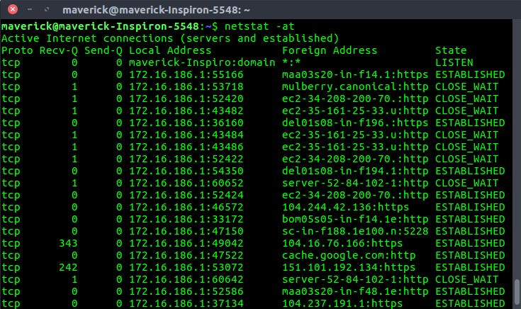

Input: netstat -au
Output: To list all udp ports.
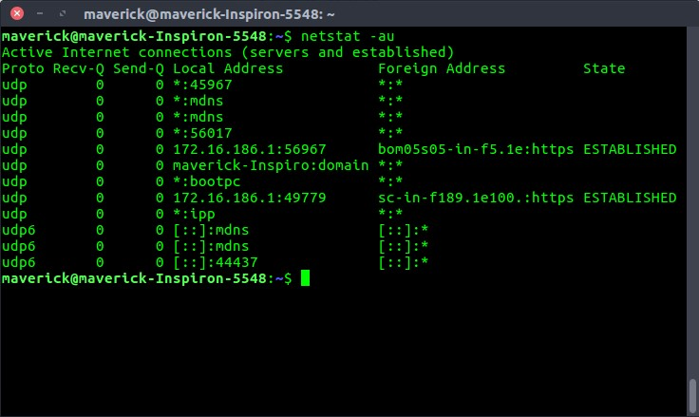

Input : netstat -s
Output: To list the statistics for all the ports.
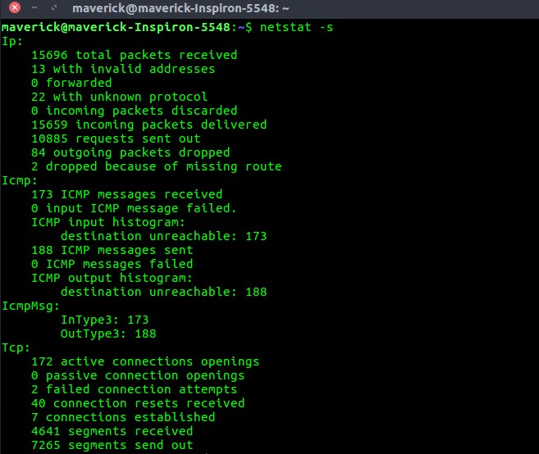

ifconfig:
Description : Ifconfig is used to configure the kernel-resident network interfaces. It is used at boot time to set up interfaces as necessary. After that, it is usually only needed when debugging or when system tuning is needed.
If no arguments are given, ifconfig displays the status of the currently active interfaces. If a single interface argument is given, it displays the status of the given interface only; if a single -a argument is given, it displays the status of all interfaces, even those that are down. Otherwise, it configures an interface.
Input : ifconfig Output : enp2s0 Link encap:Ethernet HWaddr a0:d3:c1:10:de:96 inet addr:10.10.30.64 Bcast:10.10.30.255 Mask:255.255.255.0 inet6 addr: fe80::81b6:260a:df1:8e93/64 Scope:Link
UP BROADCAST RUNNING MULTICAST MTU:1500 Metric:1
RX packets:48932 errors:0 dropped:0 overruns:0 frame:0 TX packets:31655 errors:0 dropped:0 overruns:0 carrier:0 collisions:0 txqueuelen:1000
RX bytes:54351233 (54.3 MB) TX bytes:3142083 (3.1 MB) lo Link encap:Local Loopback inet addr:127.0.0.1 Mask:255.0.0.0 inet6 addr: ::1/128 Scope:Host
UP LOOPBACK RUNNING MTU:65536 Metric:1
RX packets:3509 errors:0 dropped:0 overruns:0 frame:0 TX packets:3509 errors:0 dropped:0 overruns:0 carrier:0 collisions:0 txqueuelen:1
RX bytes:344559 (344.5 KB) TX bytes:344559 (344.5 KB) nslookup
Description :
Nslookup is a program to query Internet domain name servers. Nslookup has two modes: interactive and non-interactive. Interactive mode allows the user to query name servers for information about various hosts and domains or to print a list of hosts in a domain. Noninteractive mode is used to print just the name and requested information for a host or domain. Input : nslookup www.google.com Output :
Server: 127.0.1.1
Address: 127.0.1.1#53
Non-authoritative answer:
Name: www.google.com Address: 172.217.163.196 traceroute
Description :
Traceroute tracks the route packets taken from an IP network on their way to a given host. It utilizes the IP protocol's time to live (TTL) field and attempts to elicit an ICMP TIME_EXCEEDED response from each gateway along the path to the host.
Input : traceroute www.google.com Output :
traceroute to www.google.com (172.217.163.196), 30 hops max, 60 byte packets 192.168.1.2 (192.168.1.2) 0.517 ms 0.557 ms 0.556 ms

4.0 RESULT:

EX NO: 2A
DATE: SIMULATING PING COMMANDS
1.0 AIM:
To write the java program for simulating ping command..
2.0 ALGORITHM:
- Start the program.
- Include necessary package in java.
- To create a process object p to implement the ping command.
- Declare one BufferedReader stream class object.
- Get the details of the server
5.1: length of the IP address.
5.2: time required to get the details.
5.3: send packets, receive packets and lost packets.
5.4: minimum, maximum and average times.
- Print the results.
- Stop the program.

3.0 PROGRAM:
package ping; import java.io.*; import java.net.*;
public class Ping
{
public static void main(String[] args)
{ try
{
String str;
System.out.print(" Enter the IP Address to be Ping : ");
BufferedReader buf1=new BufferedReader(new InputStreamReader(System.in));
String ip=buf1.readLine();
Runtime H=Runtime.getRuntime();
Process p=H.exec("ping " + ip);
InputStream in=p.getInputStream();
BufferedReader buf2=new BufferedReader(new
InputStreamReader(in)); while((str=buf2.readLine())!=null)
{
System.out.println(" " + str);
}
}
catch(Exception e)
{
System.out.println(e.getMessage());
}
}
}
OUTPUT:
Enter the IP Address to be Ping : 10.10.30.47 PING 10.10.30.47 (10.10.30.47) 56(84) bytes of data.
64 bytes from 10.10.30.47: icmp_seq=1 ttl=128 time=2.24 ms
64 bytes from 10.10.30.47: icmp_seq=2 ttl=128 time=1.96 ms
64 bytes from 10.10.30.47: icmp_seq=3 ttl=128 time=0.193 ms
64 bytes from 10.10.30.47: icmp_seq=4 ttl=128 time=0.199 ms
64 bytes from 10.10.30.47: icmp_seq=5 ttl=128 time=0.524 ms

4.0 RESULT

EX NO :2B
DATE: SIMULATING TRACEROUTE COMMAND
1.0 AIM:
To write a java program to simulate Traceroute command.

2.0 ALGORITHM:
  - Start the program and declare the variables.
  - Create the document file path.txt and give the all details
  - Open the document file path.txt and compare the input with the details in the path.txt
  - Trace the route
  - Stop the program

3.0 PROGRAM:
import java.io.*; import java.net.*; import java.lang.*;
class Traceroute
{
public static void main(String args[]){
BufferedReader in; try{
Runtime r = Runtime.getRuntime();
Process p = r.exec("tracert www.google.com");
in = new BufferedReader(new InputStreamReader(p.getInputStream()));
String line; if(p==null)
System.out.println("could not connect"); while((line=in.readLine())!=null){
System.out.println(line);
//in.close();
}
}catch(IOException e){
System.out.println(e.toString());
}
}
}

OUTPUT
Tracing route to www.google.com [74.125.28.106] over a maximum of 30 hops:

- 70 ms 55 ms 70 ms 10.228.129.13
- 87 ms 84 ms 10.228.149.14
- 82 ms 85 ms 116.202.226.145 4 95 ms 94 ms 136 ms 10.228.158.82 5 Request timed out.
- 53 ms 55 ms 59 ms 116.202.226.21
- 85 ms 74 ms 82 ms 72.14.205.145
- 76 ms 75 ms 71 ms 72.14.235.69
- 124 ms 114 ms 113 ms 216.239.63.213
- 181 ms 194 ms 159 ms 66.249.95.132
- 285 ms 247 ms 246 ms 209.85.142.51
- 288 ms 282 ms 283 ms 72.14.233.138
- 271 ms 283 ms 274 ms 64.233.174.97
- Request timed out.
- 269 ms 273 ms 283 ms pc-in-f106.1e100.net [74.125.28.106] Trace complete.

4.0 RESULT

EX NO : 3
DATE : CREATE A SOCKET FOR HTTP FOR WEB PAGE UPLOAD AND

DOWNLOAD
1.0 AIM:
To write a java program for socket for HTTP for web page upload and download .

2.0 ALGORITHM:
    - Start the program.
    - Get the frame size from the user
    - To create the frame based on the user request.
    - To send frames to server from the client side.
    - If your frames reach the server it will send ACK signal to client otherwise it will send NACK signal to client.
    - Stop the program

3.0 PROGRAM:
client.java import javax.imageio.*; import java.io.*; import java.awt.image.BufferedImage; import java.io.ByteArrayOutputStream;
import java.io.File; import java.io.IOException; import javax.imageio.ImageIO;
public class Client
{
public static void main(String args[]) throws Exception
{
Socket soc;
BufferedImage img = null; soc=new Socket("localhost",4015); System.out.println("Client is running. "); try
{
System.out.println("Reading image from disk. "); img = ImageIO.read(new File("/home/s/image/karuppu.jpeg")); ByteArrayOutputStream baos = new ByteArrayOutputStream();
ImageIO.write(img, "jpg", baos); baos.flush();
byte[] bytes = baos.toByteArray(); baos.close(); System.out.println("Sending image to server. ");
OutputStream out = soc.getOutputStream();
DataOutputStream dos = new DataOutputStream(out);
dos.writeInt(bytes.length); dos.write(bytes, 0, bytes.length);
System.out.println("Image sent to server. "); dos.close(); out.close();
}
catch (Exception e)
{
System.out.println("Exception: " + e.getMessage()); soc.close();
}
soc.close();
}
}
Server.java package web; import java.net.*; import java.io.*; import java.awt.image.*; import javax.imageio.*; import javax.swing.*; public class Server
{
public static void main(String args[]) throws Exception
{
ServerSocket server=null;
Socket socket;
server=new ServerSocket(4015);
System.out.println("Server Waiting for image");
socket=server.accept(); System.out.println("Client connected.");
InputStream in = socket.getInputStream(); DataInputStream dis = new DataInputStream(in);
int len = dis.readInt();
System.out.println("Image Size: " + len/1024 + "KB"); byte[] data = new byte[len]; dis.readFully(data); dis.close(); in.close();
InputStream ian = new ByteArrayInputStream(data);
BufferedImage bImage = ImageIO.read(ian);
JFrame f = new JFrame("Server");
ImageIcon icon = new ImageIcon(bImage); JLabel l = new Jlabel(); l.setIcon(icon);
f.add(l);
f.pack();
f.setVisible(true);
}
}
OUTPUT:
CLIENT SIDE
Client is running.
Reading image from disk.
Sending image to server.
Image sent to server.
SERVER SIDE
Server Waiting for image Client connected.
Image Size: 2KB
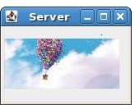

4.0 RESULT:

EX NO : 4A
DATE : APPLICATIONS USING TCP SOCKETS LIKE ECHO CLIENT AND
ECHO SERVER
1.0 AIM :
To write a program in java to implement TCP Echo Client Server (Iterative model).

2.0 ALGORITHM :

Server
- Create a server socket.
- Wait for client to be connected.
- Read text from the client
- Echo the text back to the client.
- Repeat steps 4-5 until ‘bye’ or ‘null’ is read.
- Close the I/O streams
- Close the server socket
- Stop Client:
1. Create a socket and establish connection with the server 2. Get input from user.
- If equal to bye or null, then go to step 7.
- Send text to the server.
- Display the text echoed by the server
- Repeat steps 2-4
- Close the I/O streams
- Close the client socket
- Stop
3.0 PROGRAM SERVER
import java.io.*; import java.net.*; public class EchoServer
{
public EchoServer(int portnum)
{
try
{
server = new ServerSocket(portnum);
}
catch (Exception err)
{
System.out.println(err);
}
}

public void serve()
{ try
{
while (true)
{
Socket client = server.accept();
BufferedReader r = new BufferedReader(new
InputStreamReader(client.getInputStream()));
PrintWriter w = new PrintWriter(client.getOutputStream(), true);
w.println("Welcome to the Java EchoServer. Type 'bye' toclose.");
String line;
do
{
line = r.readLine(); if ( line != null )
w.println("Got: "+ line);
}
while ( !line.trim().equals("bye") );
client.close();
}
}
catch (Exception err)
{
System.err.println(err);
}
}

public static void main(String[] args)
{
EchoServer s = new EchoServer(9999); s.serve();
}

private ServerSocket server;
}

CLIENT
import java.io.*; import java.net.*; public class EchoClient
{
public static void main(String[] args)
{ try
{
Socket s = new Socket("127.0.0.1", 9999);
BufferedReader r = new BufferedReader(new InputStreamReader(s.getInputStream()));
PrintWriter w = new PrintWriter(s.getOutputStream(), true);
BufferedReader con = new BufferedReader(newInputStreamReader(System.in));
String line;
do
{
line = r.readLine(); if ( line != null ) System.out.println(line); line = con.readLine(); w.println(line);
}
while ( !line.trim().equals("bye") );
}
catch (Exception err)
{
System.err.println(err);
}
}
}

OUTPUT:
SERVER
EchoServer
:/>javac EchoServer.java
:/>java EchoServer
CLIENT
:/>javac EchoClient.java
:/>java EchoClient
Welcome to the Java EchoServer. Type 'bye' to close.
HAI
Got: HAI
Hello Got: Hello bye
Press any key to continue ….

4.0 RESULT:

EX NO : 4B
DATE: APPLICATIONS USING TCP SOCKETS LIKE CHAT
1.0 AIM :
To write a java program to perform the full duplex chat by sending and receiving the message from the client to server and vice versa using TCP sockets.
2.0 ALGORITHM :
Server
- A TCP socket is created.
- An Internet socket address structure is filled in with the wildcard address (INADDR_ANY) and the server’s well-known port (PORT).
- The socket is converted into a listening socket by calling the listen function.
- The server blocks in the call to accept, waiting for the client connection to complete.
- When the connection is established, the server reads the line from the client using connected socket and display the message in the standard output using fputs.
- Then again the server reads a line of text from the standard input and writes it back to the client through the connected socket.
- The server went through the steps (5) and (6) until it receives 'bye' either from the standard input or client.
- Finally, the server closes the connected socket. Client
- A TCP socket is created.
- An Internet socket address structure is filled in with the server’s IP address and the same port number.
- The connect function establishes the connection with the server.
- When the connection is established, the client reads the line from the standard input using fgets and send the message to the server through the socket.
- Then again the client reads a line of text from the server through the connected socket and writes it back to the standard output using fputs.
- The client went through the steps (4) and (5) until it receives 'bye' either from the standard input or server.
- Finally, the client closes the connected socket.

3.0 PROGRAM SERVER
import java.net.*; import java.io.*; public class Server1
{
public static void main( String args[]) throws Exception
{
ServerSocket srs = new ServerSocket(1234);
System.out.println("Server is running...");
Socket ss=srs.accept();
System.out.println("connection establised");
BufferedReader kb = new BufferedReader(new InputStreamReader(System.in));
BufferedReader br = new BufferedReader(new InputStreamReader(ss.getInputStream()));
DataOutputStream dos = new DataOutputStream(ss.getOutputStream());
while(true)
{
//System.out.println("server repeat as long as client not send null");
String s2,s3;
while((s2=br.readLine())!=null)
{
System.out.println("Client said : "+s2); System.out.println("Enter text "); s3 = kb.readLine();
//System.out.println("Answer send to client machine"); dos.writeBytes(s3+"\n");
}
System.out.println("Terminated..");
ss.close(); srs.close(); dos.close(); kb.close(); System.exit(0);
}
}
}
CLIENT
import java.net.*; import java.io.*; public class Client1
{
public static void main( String args[]) throws Exception
{
Socket cs = new Socket("localhost",1234);
BufferedReader kb = new BufferedReader(new InputStreamReader(System.in));
BufferedReader br = new BufferedReader(new InputStreamReader(cs.getInputStream()));
DataOutputStream dos = new DataOutputStream(cs.getOutputStream());
System.out.println(" Enter text..");
System.out.println(" if client 'quit' type exit"); String s1,s4=null;
while(!(s1=kb.readLine()).equals("exit"))
{
//System.out.println(" data send to server machine");
dos.writeBytes(s1+"\n");
s4 = br.readLine();
//System.out.println(" data receive from server machine"); System.out.println("Server said : "+s4);
System.out.println("Enter text ");

}
System.out.println("Terminated.."); cs.close(); dos.close();
kb.close();
}
}
OUTPUT
//Server
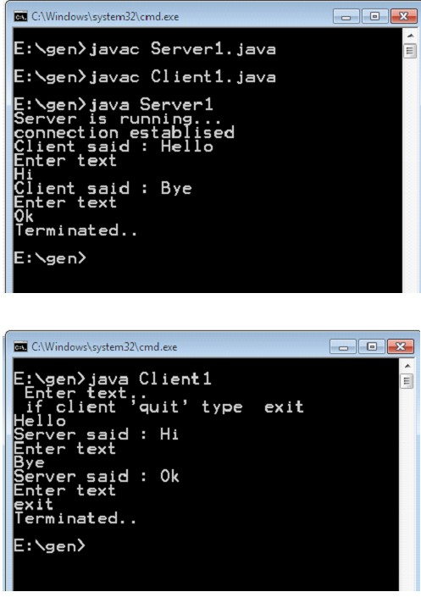

4.0 RESULT

EX NO : 4C
DATE: APPLICATIONS USING TCP SOCKETS LIKE FILE TRANSFER
1.0 AIM:
To write a java program to transfer file using TCP Sockets
2.0 ALGORITHM: SERVER:
- Start the program, declare variables
- Create a socket using the socket structure socket(AF_INET, SOCK_STREAM,0)
- Set the socket family, IP address and the port using the server address
- Set the socket address of 8 bytes to zero using the memset() function
- Bind and listen the socket structure
- Accept the client connection using the socket descriptor and the server address
- Get the file name to be transferred, the server search the file and send the file into the client and then close the connection
- Compile and Execute the program
CLIENT
- Start the program
- Create a socket using socket(AF_INET, SOCK_STREAM,0)
- Set the 8 bytes address to be zero using memset() function set the socket address family and port using servaddr
- Establish connection with the server, read the filename to be retrieved from server
- Receive the file from the server and read the contents of the received file
3.0 PROGRAM SERVER
import java.net.*; import java.io.*;
public class ContentsServer
{
public static void main(String args[]) throws Exception
{
// establishing the connection with the server
ServerSocket sersock = new ServerSocket(4000);
System.out.println("Server ready for connection");
Socket sock = sersock.accept(); // binding with port: 4000
System.out.println("Connection is successful and wating for chatting");
// reading the file name from client
InputStream istream = sock.getInputStream( );
BufferedReader fileRead =new BufferedReader(new InputStreamReader(istream));
String fname = fileRead.readLine( );
// reading file contents
BufferedReader contentRead = new BufferedReader(new FileReader(fname) );
// keeping output stream ready to send the contents
OutputStream ostream = sock.getOutputStream( );
PrintWriter pwrite = new PrintWriter(ostream, true);
String str;
while((str = contentRead.readLine()) != null) // reading line-by-line from file
{
pwrite.println(str); // sending each line to client
}

sock.close();
sersock.close(); // closing network sockets pwrite.close(); fileRead.close();
contentRead.close();
}
}
CLIENT

import java.net.*; import java.io.*; public class ContentsClient
{
public static void main( String args[ ] ) throws Exception
{
Socket sock = new Socket( "127.0.0.1", 4000);
// reading the file name from keyboard. Uses input stream
System.out.print("Enter the file name");
BufferedReader keyRead = new BufferedReader(new InputStreamReader(System.in));
String fname = keyRead.readLine();
// sending the file name to server. Uses PrintWriter
OutputStream ostream = sock.getOutputStream( ); PrintWriter pwrite = new PrintWriter(ostream, true); pwrite.println(fname);
// receiving the contents from server. Uses input stream
InputStream istream = sock.getInputStream();
BufferedReader socketRead = new BufferedReader(new InputStreamReader(istream));
String str;
while((str = socketRead.readLine()) != null) // reading line-by-line
{
System.out.println(str);
}
pwrite.close(); socketRead.close(); keyRead.close();
}
}
OUTPUT:

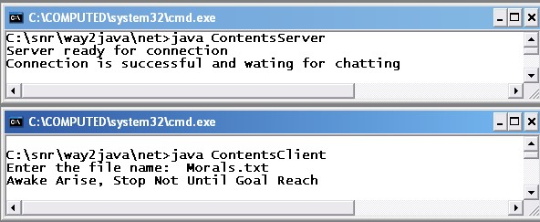

4.0 RESULT

EX NO : 5
DATE: APPLICATIONS USING TCP AND UDP SOCKETS LIKE DNS
1.0 AIM:
To write a java program to implement Domain Name System using TCP/UDPSockets.

2.0 ALGORITHM: SERVER
- Start the program.
- Create the Socket for the Server. Bind the Socket to the Port.
- Listen for the incoming client connection.
- Receive the IP address from the client to be resolved.
- Get the domain name from the client.
- Check the existence of the domain in the server.
- If domain matches then send the corresponding address to the client.
- Stop the program execution.

CLIENT
- Start the program.
- Create the Socket for the client.
Connect the Socket to the server.
- Send the hostname to the server to be resolved.
- If the server responds the print the address and terminates the process.

3.0 PROGRAM SERVER
import java.io.*; import java.net.*; public class udpdnsserver
{
private static int indexOf(String[] array, String str)
{
str = str.trim();
for (int i=0; i < array.length; i++)
{
if (array[i].equals(str)) return i; } return -1; }
public static void main(String arg[])throws IOException {
String[] hosts = {"yahoo.com", "gmail.com","cricinfo.com", "facebook.com"};
String[] ip = {"68.180.206.184", "209.85.148.19","80.168.92.140", "69.63.189.16"};
System.out.println("Press Ctrl + C to Quit"); while (true)
DatagramSocket serversocket=new DatagramSocket(1362);
byte[] senddata = new byte[1021]; byte[] receivedata = new byte[1021];
DatagramPacket recvpack = new DatagramPacket(receivedata, receivedata.length); serversocket.receive(recvpack);
String sen = new String(recvpack.getData()); InetAddress ipaddress = recvpack.getAddress();
int port = recvpack.getPort();
String capsent;
System.out.println("Request for host " + sen); if(indexOf (hosts, sen) != -1) capsent = ip[indexOf (hosts, sen)]; else
capsent = "Host Not Found"; senddata = capsent.getBytes();
DatagramPacket pack = new DatagramPacket (senddata, senddata.length,ipaddress,port); serversocket.send(pack); serversocket.close();
}
}

CLIENT
Udpdnsclient.java import java.io.*; import java.net.*; public class udpdnsclient
{
public static void main(String args[])throws IOException
{
BufferedReader br = new BufferedReader(new InputStreamReader(System.in)); DatagramSocket clientsocket = new DatagramSocket(); InetAddress ipaddress; if (args.length == 0) ipaddress = InetAddress.getLocalHost(); else
ipaddress = InetAddress.getByName(args[0]); byte[] senddata = new byte[1024];
String sentence = br.readLine();
Senddata = sentence.getBytes();
DatagramPacket pack = new DatagramPacket(senddata,senddata.length, ipaddress,portaddr); clientsocket.send(pack);
DatagramPacket recvpack =new DatagramPacket(receivedata,receivedata.length); clientsocket.receive(recvpack);
String modified = new String(recvpack.getData()); System.out.println("IP Address: " + modified); clientsocket.close();
}
}

OUTPUT
Server javac udpdnsserver.java java udpdnsserver
Press Ctrl + C to Quit Request for host yahoo.com
Request for host cricinfo.com
Request for host youtube.com Client
javac udpdnsclient.java java udpdnsclient
Enter the hostname : yahoo.com IP Address: 68.180.206.184 java udpdnsclient
Enter the hostname : cricinfo.com IP Address: 80.168.92.140 java udpdnsclient
Enter the hostname : youtube.com
IP Address: Host Not Found

4.0 RESULT

EX NO : 6
DATE: SIMULATING ARP / RARP PROTOCOLS

1.0 AIM:
To write a java program to implement Address Resolution Protocol/Reverse Address Resolution Protocol.

2.0 ALGORITHM:
SERVER
1.Start the program
2.Accept the socket which is created by the client.
3.Server maintains the table in which IP and corresponding MAC addresses are stored.
4.Read the IP address which is send by the client.
5.Map the IP address with its MAC address and return the MAC address to client.

CLIENT
1. Start the program
2.Using socket connection is established between client and server.
3.Get the IP address to be converted into MAC address.
4.Send this IP address to server.
5.Server returns the MAC address to client.
3.0 PROGRAM:
SERVER:
import java.io.*; import java.net.*; import java.util.*; class Serverarp
{
public static void main(String args[])
{ try {
ServerSocket obj=new ServerSocket(139); Socket obj1=obj.accept(); while(true)
{
DataInputStream din=new DataInputStream(obj1.getInputStream());
DataOutputStream dout=new DataOutputStream(obj1.getOutputStream());
String str=din.readLine();
String ip[]={"165.165.80.80","165.165.79.1"}; String mac[]={"6A:08:AA:C2","8A:BC:E3:FA"};
for(int i=0;i<ip.length;i++)
{
if(str.equals(ip[i]))
{
dout.writeBytes(mac[i]+'\n'); break; } } obj.close();
} }
catch(Exception e)
{
System.out.println(e);
}
}
}
CLIENT:
import java.io.*; import java.net.*; import java.util.*; class Clientarp
{
public static void main(String args[])
{ try
{
BufferedReader in=new BufferedReader(new InputStreamReader(System.in));
Socket clsct=new Socket("127.0.0.1",139);
DataInputStream din=new DataInputStream(clsct.getInputStream());
DataOutputStream dout=new DataOutputStream(clsct.getOutputStream());
System.out.println("Enter the Logical address(IP):"); String str1=in.readLine(); dout.writeBytes(str1+'\n');
String str=din.readLine();
System.out.println("The Physical Address is: "+str); clsct.close(); }
catch (Exception e)
{
System.out.println(e);
}
}
}
OUTPUT:
SERVER SIDE
E:\networks>java Serverarp

CLIENT SIDE

E:\networks>java Clientarp
Enter the Logical address(IP): 165.165.80.80
The Physical Address is: 6A:08:AA:C2

4.0 RESULT

EX NO : 7A
DATE: STUDY OF NETWORK SIMULATOR (NS2)
1.0 AIM:
To study ns2 in detail.
2.0 DESCRIPTION:
ns is an object oriented simulator, written in C++, with an OTcl interpreter as a frontend. The simulator supports a class hierarchy in C++ (also called the compiled hierarchy in this document), and a similar class hierarchy within the OTcl interpreter (also called the interpreted hierarchy in this document). The two hierarchies are closely related to each other; from the user’s perspective, there is a one-to-one correspondence between a class in the interpreted hierarchy and one in the compiled hierarchy.
The root of this hierarchy is the class TclObject. Users create new simulator objects through the interpreter; these objects are instantiated within the interpreter, and are closely mirrored by a corresponding object in the compiled hierarchy. The interpreted class hierarchy is automatically established through methods defined in the class TclClass. User instantiated objects are mirrored through methods defined in the class TclObject. There are other hierarchies in the C++ code and OTcl scripts; these other hierarchies are not mirrored in the manner of TclObject.
CONCEPT OVERVIEW:
ns uses two languages because simulator has two different kinds of things it needs to do. On one hand, detailed simulations of protocols require a systems programming language which can efficiently manipulate bytes, packet headers, and implement algorithms that run over large data sets. For these tasks run-time speed is important and turn-around time (run simulation, find bug, fix bug, recompile, re-run) is less important. On the other hand, a large part of network research involves slightly varying parameters or configurations, or quickly exploring a number of scenarios.
In these cases, iteration time (change the model and re-run) is more important. Since configuration runs once (at the beginning of the simulation), run-time of this part of the task is less important. ns meets both of these needs with two languages, C++ and OTcl. C++ is fast to run but slower to change, making it suitable for detailed protocol implementation. OTcl runs much slower but can be changed very quickly (and interactively), making it ideal for simulation configuration. ns (via tclcl) provides glue to make objects and variables appear on both languages.

SIMULATOR INITIALIZATION:
When a new simulation object is created in tcl, the initialization procedure performs the following operations:
- initialize the packet format (calls create_packetformat)
- create a scheduler (defaults to a calendar scheduler)
- create a “null agent” (a discard sink used in various places)
SCHEDULERS AND EVENTS:
The simulator is an event-driven simulator. There are presently four schedulers available in the simulator, each of which is implemented using a different data structure: a simple linked-list, heap, calendar queue (default), and a special type call called “real-time”. Each of these is described below. The scheduler runs by selecting the next earliest event, executing it to completion and returning to execute the next event. Unit of time used by scheduler is seconds. Presently, the simulator is single-threaded and only one event in execution at any given time. If more than one event are scheduled to execute at the same time, their execution is performed on the first scheduled – first dispatched manner. Simultaneous events are not reordered anymore by schedulers (as it was in earlier versions) and all schedulers should yeild the same order of dispatching given the same input.
NODE BASICS:
The basic primitive for creating a node is set ns [new Simulator]
$ns node
The instance procedure node constructs a node out of simpler classifier objects (Section 5.4). The Node itself is a standalone class in OTcl. However, most of the components of the node are themselves TclObjects. The typical structure of a (unicast) node is as shown in Figure 5.1. This simple structure consists of two TclObjects: an address classifer (classifer_) and a port classifier (dmux_). The function of these classifiers is to distribute incoming packets to the correct agent or outgoing link.
All nodes contain at least the following components:
- an address or id_, monotonically increasing by 1 (from initial value 0) across the simulation namespace as nodes are created,
- a list of neighbors (neighbor_)

3.0 BASIC COMMANDS IN NS2:
set ns [new Simulator]: generates an NS simulator object instance, and assigns it to variable ns.The "Simulator" object has member functions that do the following:
    - Create compound objects such as nodes and links (described later)
    - Connect network component objects created (ex. attach-agent)
    - Set network component parameters (mostly for compound objects)
    - Create connections between agents (ex. make connection between a "tcp" and "sink")
    - Specify NAM display options
    - Most of member functions are for simulation setup (referred to as plumbing functions in the Overview section) and scheduling, however some of them are for the NAM display. The "Simulator" object member function implementations are locatedinthefilens-2/tcl/lib/ns-lib.tcl"

    - $ns color fid color: is to set color of the packets for a flow specified by the flow id (fid). This member function of "Simulator" object is for the NAM display, and has no effect on the actual simulation.

    - $ns namtrace-all file-descriptor: This member function tells the simulator to record simulation traces in NAM input format. It also gives the file name that the trace will be written to later by the command $ns flush-trace. Similarly, the member function traceall is for recording the simulation trace in a general format

    - proc finish {}: is called after this simulation is over by the command $ns at 5.0 "finish". In this function, post-simulation processes are specified.

    - set n0 [$ns node]: The member function node creates a node. A node in NS is compound object made of address and port classifiers (described in a later section). Users can create a node by separately creating an address and a port classifier objects and connecting them together. However, this member function of Simulator object makes the job easier.
    - To see how a node is created, look at the files: "ns-2/tcl/libs/ns-lib.tcl"andns2/tcl/libs/ns-node.tcl".
$ns duplex-link node1 node2 bandwidth delay queue-type: creates two simplex links of specified bandwidth and delay, and connects the two specified nodes. In NS, the output queue of a node is implemented as a part of a link, therefore users should specify the queue-type when creating links. In the above simulation script, DropTail queue is used. If the reader wants to use a RED queue, simply replace the word DropTail with RED. The NS implementation of a link is shown in a later section. Like a node, a link is a compound object, and users can create its sub-objects and connect them and the nodes. Link source codes can be found in "ns-2/tcl/libs/ns-lib.tcl" and "ns-2/tcl/libs/nslink.tcl" files. One thing to note is that you can insert error modules in a link component to simulate a lossy link (actually users can make and insert any network objects)
    - $ns queue-limit node1 node2 number: This line sets the queue limit of the two simplex links that connect node1 and node2 to the number specified. At this point, the authors do not know how many of these kinds of member functions of Simulator objects are available and what they are. Please take a look at "ns-2/tcl/libs/ns-lib.tcl" and "ns2/tcl/libs/ns-link.tcl", or NS.
    - $ns duplex-link-op node1 node2 ...: The next couple of lines are used for the NAM display. To see the effects of these lines, users can comment these lines out and try the simulation.
    - Now that the basic network setup is done, the next thing to do is to setup traffic agents such as TCP and UDP, traffic sources such as FTP and CBR, and attach them to nodes and agents respectively.
    - set tcp [new Agent/TCP]: This line shows how to create a TCP agent. But in general, users can create any agent or traffic sources in this way. Agents and traffic sources are in fact basic objects (not compound objects), mostly implemented in C++ and linked to OTcl. Therefore, there are no specific Simulator object member functions that create these object instances. To create agents or traffic sources, a user should know the class names these objects (Agent/TCP, Agnet/TCPSink, Application/FTP and so on). This information can be found in the NS documentation or partly in this documentation. But one shortcut is to look at the "ns2/tcl/libs/ns-default.tcl" file. This file contains the default configurable parameter value settings for available network objects. Therefore, it works as a good indicator of what kind of network objects is available in NS and what are the configurable parameters.

    - $ns attach-agent node agent: The attach-agent member function attaches an agent object created to a node object. Actually, what this function does is call the attach member function of specified node, which attaches the given agent to itself. Therefore, a user can do the same thing by, for example, $n0 attach $tcp. Similarly, each agent object has a member function .
    - $ns connect agent1 agent2: After two agents that will communicate with each other are created, the next thing is to establish a logical network connection between them. This line establishes a network connection by setting the destination address to each others' network and port address pair.
    - Assuming that all the network configuration is done, the next thing to do is write a simulation scenario (i.e. simulation scheduling). The Simulator object has many scheduling member functions. However, the one that is mostly used is the following:
    - $ns at time "string": This member function of a Simulator object makes the scheduler (scheduler_ is the variable that points the scheduler object created by [new Scheduler] command at the beginning of the script) to schedule the execution of the specified string at given simulation time. For example, $ns at 0.1 "$cbr start" will make the scheduler call a start member function of the CBR traffic source object, which starts the CBR to transmit data. In NS, usually a traffic source does not transmit actual data, but it notifies the underlying agent that it has some amount of data to transmit, and the agent, just knowing how much of the data to transfer, creates packets and sends them.
    - After all network configurations, scheduling and post-simulation procedure specifications are done, the only thing left is to run the simulation. This is done by $ns run.

4.0 RESULT

EX NO 7B
DATE: STUDY OF TCP/UDP PERFORMANCE USING SIMULATION TOOL
1.0 AIM:
To study the performance comparison of User Datagram Protocol and Transmission Control Protocol
UDP
2.0 Introduction :
The User Datagram Protocol (UDP) is one of the core members of the Internet Protocol Suite, the set of network protocols used for the Internet. With UDP, computer applications can send messages, in this case referred to as datagrams, to other hosts on an Internet Protocol (IP) network without requiring prior communications to set up special transmission channels or data paths. UDP is sometimes called the Universal Datagram Protocol. The protocol was designed by David P. Reed in 1980 and formally defined in RFC 768.
UDP uses a simple transmission model without implicit hand-shaking dialogues for guaranteeing reliability, ordering, or data integrity. Thus, UDP provides an unreliable service and datagrams may arrive out of order, appear duplicated, or go missing without notice. UDP assumes that error checking and correction is either not necessary or performed in the application, avoiding the overhead of such processing at the network interface level. Time-sensitive applications often use UDP because dropping packets is preferable to waiting for delayed packets, which may not be an option in a real-time system. If error correction facilities are needed at the network interface level, an application may use the Transmission Control Protocol (TCP) or Stream Control Transmission Protocol (SCTP) which are designed for this purpose.
UDP's stateless nature is also useful for servers that answer small queries from huge numbers of clients. Unlike TCP, UDP is compatible with packet broadcast (sending to all on local network) and multicasting (send to all subscribers).Common network applications that use UDP include: the Domain Name System (DNS), streaming media applications such as IPTV, Voice over IP (VoIP), Trivial File Transfer Protocol (TFTP) and many online games.
Packet structure :
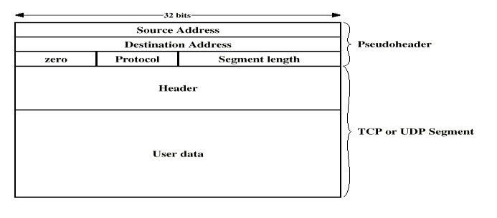
UDP is a minimal message-oriented Transport Layer protocol that is documented in IETF RFC 768.UDP provides no guarantees to the upper layer protocol for message delivery and the UDP protocol layer retains no state of UDP messages once sent. For this reason, UDP is sometimes referred to as Unreliable Datagram Protocol.UDP provides application multiplexing (via port numbers) and integrity verification (via checksum) of the header and payload. If transmission reliability is desired, it must be implemented in the user's application.
The UDP header consists of 4 fields, all of which are 2 bytes (16 bits).
Reliability and congestion control solutions:
Lacking reliability, UDP applications must generally be willing to accept some loss, errors or duplication. Some applications such as TFTP may add rudimentary reliability mechanisms into the application layer as needed.[2] Most often, UDP applications do not require reliability mechanisms and may even be hindered by them. Streaming media, real-time multiplayer games and voice over IP (VoIP) are examples of applications that often use UDP. If an application requires a high degree of reliability, a protocol such as the Transmission Control Protocol or erasure codes may be used instead.
Lacking any congestion avoidance and control mechanisms, network-based mechanisms are required to minimize potential congestion collapse effects of uncontrolled, high rate UDP traffic loads. In other words, since UDP senders cannot detect congestion, network-based elements such as routers using packet queuing and dropping techniques will often be the only tool available to slow down excessive UDP traffic. The Datagram Congestion Control Protocol (DCCP) is being designed as a partial solution to this potential problem by adding end host TCP-friendly congestion control behavior to high-rate UDP streams such as streaming media.
Comparison of UDP and TCP:
Transmission Control Protocol is a connection-oriented protocol, which means that it requires handshaking to set up end-to-end communications. Once a connection is set up user data may be sent bidirectionally over the connection.
Reliable – TCP manages message acknowledgment, retransmission and timeout. Multiple attempts to deliver the message are made. If it gets lost along the way, the server will re-request the lost part. In TCP, there's either no missing data, or, in case of multiple timeouts, the connection is dropped.
Ordered – if two messages are sent over a connection in sequence, the first message will reach the receiving application first. When data segments arrive in the wrong order, TCP buffers the out-of-order data until all data can be properly re-ordered and delivered to the application.
Heavyweight – TCP requires three packets to set up a socket connection, before any user data can be sent. TCP handles reliability and congestion control.
Streaming – Data is read as a byte stream, no distinguishing indications are transmitted to signal message (segment) boundaries.
UDP is a simpler message-based connectionless protocol. Connectionless protocols do not set up a dedicated end-to-end connection. Communication is achieved by transmitting information in one direction from source to destination without verifying the readiness or state of the receiver.
Unreliable – When a message is sent, it cannot be known if it will reach its destination; it could get lost along the way. There is no concept of acknowledgment, retransmission or timeout.
Not ordered – If two messages are sent to the same recipient, the order in which they arrive cannot be predicted.
Lightweight – There is no ordering of messages, no tracking connections, etc. It is a small transport layer designed on top of IP.
Datagrams – Packets are sent individually and are checked for integrity only if they arrive. Packets have definite boundaries which are honored upon receipt, meaning a read operation at the receiver socket will yield an entire message as it was originally sent.
TCP
3.0 Introduction :
The Transmission Control Protocol (TCP) is one of the core protocols of the Internet Protocol Suite. TCP is one of the two original components of the suite (the other being Internet Protocol, or IP. TCP segment structure:
A TCP segment consists of a segment header and a data section. The TCP header contains 10 mandatory fields, and an optional extension field (Options, pink background in table).
The data section follows the header. Its contents are the payload data carried for the application. The length of the data section is not specified in the TCP segment header. It can be calculated by subtracting the combined length of the TCP header and the encapsulating IP segment header from the total IP segment length (specified in the IP segment header).
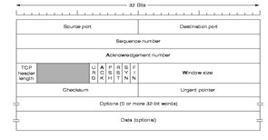

Protocol operation:
A Simplified TCP State Diagram shown below. See TCP EFSM diagram for a more detailed state diagram including the states inside the ESTABLISHED state.TCP protocol operations may be divided into three phases. Connections must be properly established in a multi-step handshake process (connection establishment) before entering the data transfer phase. After data transmission is completed, the connection termination closes established virtual circuits and releases all allocated resources.
During the lifetime of a TCP connection it undergoes a series of state changes:

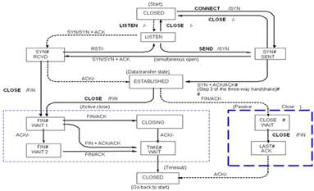
LISTEN : In case of a server, waiting for a connection request from any remote client.
SYN-SENT : waiting for the remote peer to send back a TCP segment with the SYN and ACK flags set.
(usually set by TCP clients)
SYN-RECEIVED : waiting for the remote peer to send back an acknowledgment after having sent back a connection acknowledgment to the remote peer. (Usually set by TCP servers)
ESTABLISHED : the port is ready to receive/send data from/to the remote peer.
FIN-WAIT-1
FIN-WAIT-2
CLOSE-WAIT
CLOSING
LAST-ACK
TIME-WAIT: represents waiting for enough time to pass to be sure the remote peer received the acknowledgment of its connection termination request. According to RFC 793 a connection can stay in TIME-WAIT for a maximum of four minutes.
CLOSED

Connection establishment:
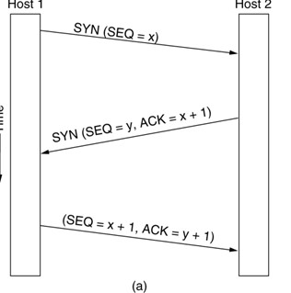
To establish a connection, TCP uses a three-way handshake. Before a client attempts to connect with a server, the server must first bind to a port to open it up for connections: this is called a passive open. Once the passive open is established, a client may initiate an active open. To establish a connection, the threeway (or 3-step) handshake occurs:
The active open is performed by the client sending a SYN to the server. It sets the segment's sequence number to a random value A.
In response, the server replies with a SYN-ACK. The acknowledgment number is set to one more than the received sequence number (A + 1), and the sequence number that the server chooses for the packet is another random number, B.
Finally, the client sends an ACK back to the server. The sequence number is set to the received acknowledgement value i.e. A + 1, and the acknowledgement number is set to one more than the received sequence number i.e. B + 1.
At this point, both the client and server have received an acknowledgment of the connection.

Connection Termination:

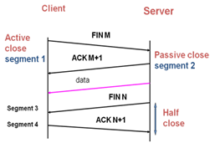
The connection termination phase uses, at most, a four-way handshake, with each side of the connection terminating independently. When an endpoint wishes to stop its half of the connection, it transmits a FIN packet, which the other end acknowledges with an ACK. Therefore, a typical tear-down requires a pair of FIN and ACK segments from each TCP endpoint.
A connection can be "half-open", in which case one side has terminated its end, but the other has not. The side that has terminated can no longer send any data into or receive any data from the connection, but the other side can (but generally if it tries, this should result in no acknowledgment and therefore a timeout, or else result in a positive RST and either way thereby the destruction of the halfopen socket).
It is also possible to terminate the connection by a 3-way handshake, when host A sends a FIN and host B replies with a FIN & ACK (merely combines 2 steps into one) and host A replies with an ACK. This is perhaps the most common method.

4.0 RESULT:

EX NO : 8A
DATE: IMPLEMENTATION OF DISTANCE VECTOR ROUTING
PROTOCOL
1.0 AIM:
To perform the simulation of the distance vector routing protocol using NS2.
2.0 ALGORITHM:
- Start the program
- Create the trace file and NAM file
- Setup the topology object
- Create mobile nodes and attach them to the channel
- Configure the nodes and provide initial location of mobile nodes
- Set up a TCP Connection between nodes
- Define and initialize positions for the NAM window 8. Specify the end of simulation
9. Stop.
3.0 PROGRAM:
set ns [new Simulator]
#Define different colors for data flows (for NAM)
$ns color 1 Blue
$ns color 2 Yellow #Open the Trace file set file1 [open out.tr w] $ns trace-all $file1
#Open the NAM trace file set file2 [open out.nam w] $ns namtrace-all $file2 #Define a 'finish' procedure proc finish {} { global ns file1 file2 $ns flush-trace close $file1 close $file2
exec nam out.nam &
exit 0
}
# Next line should be commented out to have the static routing
$ns rtproto DV #Create six nodes set n0 [$ns node] set n1 [$ns node] set n2 [$ns node] set n3 [$ns node] set n4 [$ns node] set n5 [$ns node]
#Create links between the nodes
$ns duplex-link $n0 $n4 0.3Mb 10ms DropTail
$ns duplex-link $n0 $n1 0.3Mb 10ms DropTail
$ns duplex-link $n1 $n2 0.3Mb 10ms DropTail
$ns duplex-link $n2 $n3 0.3Mb 10ms DropTail
$ns duplex-link $n1 $n4 0.3Mb 10ms DropTail
$ns duplex-link $n4 $n3 0.5Mb 10ms DropTail
$ns duplex-link $n3 $n5 0.5Mb 10ms DropTail
$ns duplex-link $n4 $n5 0.5Mb 10ms DropTail
#Give node position (for NAM)
$ns duplex-link-op $n0 $n4 orient up
$ns duplex-link-op $n0 $n1 orient right
$ns duplex-link-op $n1 $n2 orient right
$ns duplex-link-op $n2 $n3 orient up
$ns duplex-link-op $n1 $n4 orient up-left $ns duplex-link-op $n4 $n3 orient right
$ns duplex-link-op $n3 $n5 orient left-up
$ns duplex-link-op $n4 $n5 orient right-up
#Setup a TCP connection set tcp [new Agent/TCP/Newreno] $ns attach-agent $n0 $tcp set sink [new Agent/TCPSink/DelAck]
$ns attach-agent $n5 $sink
$ns connect $tcp $sink
$tcp set fid_ 1
#Setup a FTP over TCP connection set ftp [new Application/FTP]
$ftp attach-agent $tcp
$ftp set type_ FTP
$ns rtmodel-at 1.0 down $n0 $n4
$ns rtmodel-at 4.5 up $n0 $n4
$ns at 0.1 "$ftp start"
$ns at 6.0 "finish"
$ns run
OUTPUT:
Up:

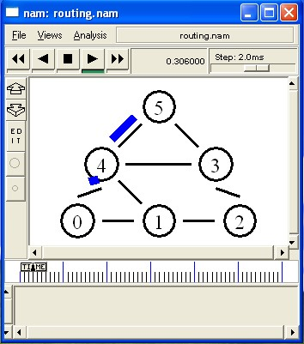

Down:
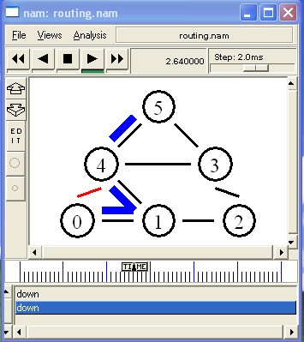
Up:
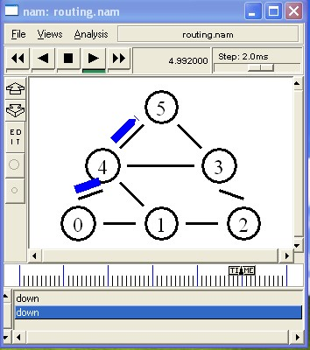

4.0 RESULT

EX: NO: 8B
DATE IMPLEMENTATION OF LINK STATE ROUTING PROTOCOL
1.0 AIM:
To perform the simulation of the link state routing protocol using NS2.
2.0 ALGORITHM:
- Define new simualtor
- Define different colors for data flows (for NAM)
- Define a new Trace file and open it
- Define a new NAM Trace file and open it
- Define a 'finish' procedure – to flush trace record in the `trace and trace output files.
- Define the routing protocol as Link State (LS)
- Create six nodes – n0,n1,..n5
- Create links between the nodes with 0.3Mb and 10 ms Link with DropTail option
- Give node position (for NAM) to place six nodes in the layout
- Setup a TCP connection – attach TCP Source Agent to node n0 and TCP sink agent to node n5
- Setup a FTP over TCP connection
- Define configuration such that link between nodes n1 and n4 to be failed at 1.0 interval, and up again at 4.5 interval 13. Start the simulation

3.0 PROGRAM:
#routing2.tcl set ns [new Simulator]
#Define different colors for data flows (for NAM)
$ns color 1 Blue
$ns color 2 Red
#Open the Trace file set file1 [open routing2.tr w] $ns trace-all $file1 #Open the NAM trace file set file2 [open routing2.nam w] $ns namtrace-all $file2 #Define a 'finish' procedure proc finish {}
{
global ns file1 file2 $ns flush-trace close $file1 close $file2 exec nam routing2.nam &
exit 0
}
# Next line should be commented out to have the static routing
$ns rtproto LS #Create six nodes set n0 [$ns node] set n1 [$ns node] set n2 [$ns node] set n3 [$ns node] set n4 [$ns node] set n5 [$ns node]
#Create links between the nodes
$ns duplex-link $n0 $n1 0.3Mb 10ms DropTail
$ns duplex-link $n1 $n2 0.3Mb 10ms DropTail
$ns duplex-link $n2 $n3 0.3Mb 10ms DropTail
$ns duplex-link $n1 $n4 0.3Mb 10ms DropTail
$ns duplex-link $n3 $n5 0.5Mb 10ms DropTail
$ns duplex-link $n4 $n5 0.5Mb 10ms DropTail
#Give node position (for NAM)
$ns duplex link-op $n0 $n1 orient right
$ns duplex-link-op $n1 $n2 orient right
$ns duplex-link-op $n2 $n3 orient up-down
$ns duplex-link-op $n1 $n4 orient up-left
$ns duplex-link-op $n3 $n5 orient left-up
$ns duplex-link-op $n4 $n5 orient right-up
#Setup a TCP connection set tcp [new Agent/TCP/Newreno] $ns attach-agent $n0 $tcp set sink [new Agent/TCPSink/DelAck]
$ns attach-agent $n5 $sink
$ns connect $tcp $sink
$tcp set fid_ 1
#Setup a FTP over TCP connection set ftp [new Application/FTP]
$ftp attach-agent $tcp
$ftp set type_ FTP
$ns rtmodel-at 1.0 down $n1 $n4
$ns rtmodel-at 3.0 up $n1 $n4
$ns at 0.1 "$ftp start"
$ns at 6.0 "finish"
$ns run
OUTPUT:
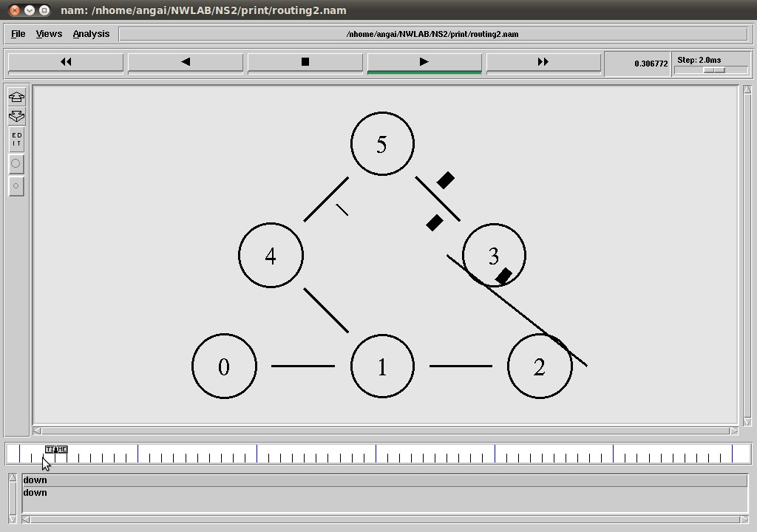
Before Link failure between Nodes n1 and n4
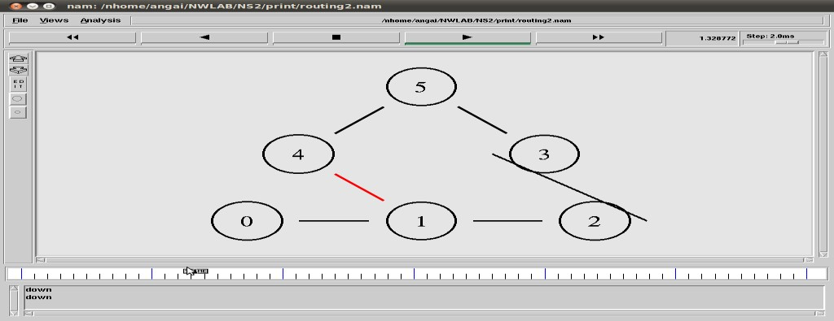
While Link failure between Nodes n1 and n4

After failed link between Nodes n1 and n4 up

4.0 RESULT:

EX NO 9
DATE: PERFORMANCE EVALUATION OF ROUTING PROTOCOLS
USING SIMULATION TOOL
1.0 AIM:
To perform the simulation of the routing protocols using NS2.
2.0 ALGORITHM:
Step 1: Start the program
Step 2: Create the trace file and NAM file
Step 3: Setup the topology object
Step 4: Create mobile nodes and attach them to the channel
Step 5: Configure the nodes and provide initial location of mobile nodes
Step 6: Set up a TCP Connection between nodes
Step 7: Define and initialize positions for the NAM window
Step 8: Specify the end of simulation Step 9: Stop.
3.0 PROGRAM
set ns [new Simulator]
#Define different colors for data flows (for NAM)
$ns color 1 Blue
$ns color 2 Yellow #Open the Trace file set file1 [open out.tr w] $ns trace-all $file1 #Open the NAM trace file set file2 [open out.nam w] $ns namtrace-all $file2 #Define a 'finish' procedure proc finish {} { global ns file1 file2 $ns flush-trace close $file1 close $file2 exec nam out.nam & exit 0
}
# Next line should be commented out to have the static routing
$ns rtproto DV #Create six nodes set n0 [$ns node] set n1 [$ns node] set n2 [$ns node] set n3 [$ns node] set n4 [$ns node] set n5 [$ns node] #Create links between the nodes
$ns duplex-link $n0 $n4 0.3Mb 10ms DropTail
$ns duplex-link $n0 $n1 0.3Mb 10ms DropTail
$ns duplex-link $n1 $n2 0.3Mb 10ms DropTail
$ns duplex-link $n2 $n3 0.3Mb 10ms DropTail
$ns duplex-link $n1 $n4 0.3Mb 10ms DropTail
$ns duplex-link $n4 $n3 0.5Mb 10ms DropTail
$ns duplex-link $n3 $n5 0.5Mb 10ms DropTail
$ns duplex-link $n4 $n5 0.5Mb 10ms DropTail
#Give node position (for NAM)
$ns duplex-link-op $n0 $n4 orient up
$ns duplex-link-op $n0 $n1 orient right
$ns duplex-link-op $n1 $n2 orient right
$ns duplex-link-op $n2 $n3 orient up
$ns duplex-link-op $n1 $n4 orient up-left $ns duplex-link-op $n4 $n3 orient right
$ns duplex-link-op $n3 $n5 orient left-up
$ns duplex-link-op $n4 $n5 orient right-up #Setup a TCP connection set tcp [new Agent/TCP/Newreno] $ns attach-agent $n0 $tcp set sink [new Agent/TCPSink/DelAck]
$ns attach-agent $n5 $sink
$ns connect $tcp $sink
$tcp set fid_ 1
#Setup a FTP over TCP connection set ftp [new Application/FTP]
$ftp attach-agent $tcp
$ftp set type_ FTP
$ns rtmodel-at 1.0 down $n0 $n4
$ns rtmodel-at 4.5 up $n0 $n4
$ns at 0.1 "$ftp start"
$ns at 6.0 "finish"
$ns run
OUTPUT:
UP:
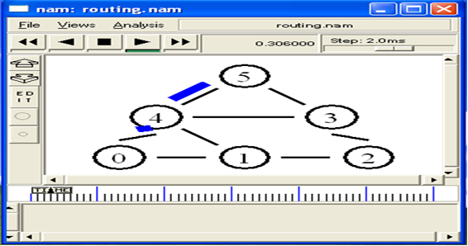
DOWN:
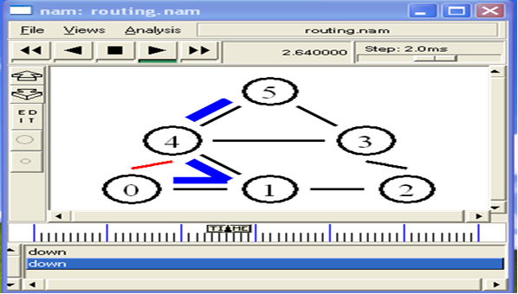
UP:
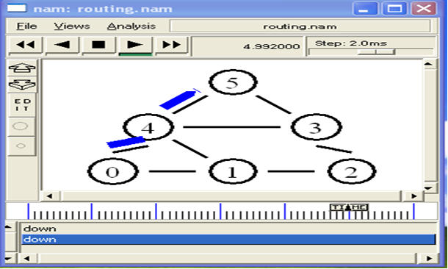

4.0 RESULT

EX NO :10(i)
DATE: SIMULATION OF FLOODING
1.0 AIM:
To simulate the performance of flooding using ns2.
2.0 ALGORITHM:
- Start the program
- Create the trace file and NAM file.
- Setup the flooding agent
- Create nodes and set duplex links between the nodes.
- Create nodes and attach them to the queue, DROPTAIL
- Configure the nodes and provides initial location of nodes. Generation of movements is done.
- Setup connection between the nodes
- Define a initialize positions for the nam window.
- Telling nodes when the simulation ends.
- Ending nam and the simulation.
3.0 PROGRAM:
Mac/Simple set bandwidth_ 1Mb set MESSAGE_PORT 42
set BROADCAST_ADDR -1
# variables which control the number of nodes and how they're grouped
# (see topology creation code below) set group_size 4 set num_groups 6 set num_nodes [expr $group_size * $num_groups] set val(chan) Channel/WirelessChannel ;#Channel Type set val(prop) Propagation/TwoRayGround ;# radio-propagation model
set val(netif) Phy/WirelessPhy ;# network interface type
#set val(mac) Mac/802_11 ;# MAC type #set val(mac) Mac ;# MAC type set val(mac) Mac/Simple
set val(ifq) Queue/DropTail/PriQueue ;# interface queue type set val(ll) LL ;# link layer type
set val(ant) Antenna/OmniAntenna ;# antenna model set val(ifqlen) 50 ;# max packet in ifq
# DumbAgent, AODV, and DSDV work. DSR is broken
set val(rp) DumbAgent #set val(rp) DSDV
#set val(rp) DSR
#set val(rp) AODV # size of the topography set val(x) [expr 120*$group_size + 500] set val(y) [expr 240*$num_groups + 200] set ns [new Simulator]
set f [open wireless-flooding-$val(rp).tr w]
$ns trace-all $f set nf [open wireless-flooding-$val(rp).nam w]
$ns namtrace-all-wireless $nf $val(x) $val(y)
$ns use-newtrace # set up topography object set topo [new Topography] $topo load_flatgrid $val(x) $val(y)
#
# Create God #
create-god $num_nodes set chan_1_ [new $val(chan)] $ns node-config -adhocRouting $val(rp) \
-llType $val(ll) \
-macType $val(mac) \
-ifqType $val(ifq) \
-ifqLen $val(ifqlen) \
-antType $val(ant) \
-propType $val(prop) \
-phyType $val(netif) \
-topoInstance $topo \
-agentTrace ON \
-routerTrace OFF \
-macTrace ON \
-movementTrace OFF \
-channel $chan_1_
# subclass Agent/MessagePassing to make it do flooding
Class Agent/MessagePassing/Flooding -superclass Agent/MessagePassing
Agent/MessagePassing/Flooding instproc recv {source sport size data} {
$self instvar messages_seen node_ global ns BROADCAST_ADDR
# extract message ID from message set message_id [lindex [split $data ":"] 0]
puts "\nNode [$node_ node-addr] got message $message_id\n" if {[lsearch $messages_seen $message_id] == -1} {
lappend messages_seen $message_id
$ns trace-annotate "[$node_ node-addr] received {$data} from $source"
$ns trace-annotate "[$node_ node-addr] sending message $message_id"
$self sendto $size $data $BROADCAST_ADDR $sport
} else {
$ns trace-annotate "[$node_ node-addr] received redundant message $message_id from $source"
}
}
Agent/MessagePassing/Flooding instproc send_message {size message_id data port} {
$self instvar messages_seen node_
global ns MESSAGE_PORT BROADCAST_ADDR
lappend messages_seen $message_id
$ns trace-annotate "[$node_ node-addr] sending message $message_id"
$self sendto $size "$message_id:$data" $BROADCAST_ADDR $port
}
# create a bunch of nodes
for {set i 0} {$i < $num_nodes} {incr i} { set n($i) [$ns node]
$n($i) set Y_ [expr 230*floor($i/$group_size) + 160*(($i%$group_size)>=($group_size/2))]
$n($i) set X_ [expr (90*$group_size)*($i/$group_size%2) + 200*($i%($group_size/2))] $n($i) set Z_ 0.0
$ns initial_node_pos $n($i) 20
}
# attach a new Agent/MessagePassing/Flooding to each node on port $MESSAGE_PORT for {set i 0} {$i < $num_nodes} {incr i} { set a($i) [new Agent/MessagePassing/Flooding]
$n($i) attach $a($i) $MESSAGE_PORT
$a($i) set messages_seen {}
}
# now set up some events
$ns at 0.2 "$a(1) send_message 200 1 {first message} $MESSAGE_PORT"
$ns at 0.4 "$a([expr $num_nodes/2]) send_message 600 2 {some big message} $MESSAGE_PORT" $ns at 0.7 "$a([expr $num_nodes-2]) send_message 200 3 {another one} $MESSAGE_PORT"
$ns at 1.0 "finish" proc finish {} { global ns f nf val $ns flush-trace close $f close $nf
# puts "running nam..."
exec nam wireless-flooding-$val(rp).nam & exit 0 }
$ns run
OUTPUT:
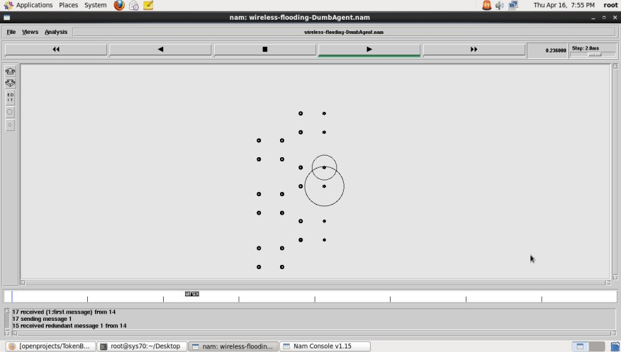

4.0 RESULT

EX: NO: 10(ii)
DATE: SIMULATION OF CONGESTION CONTROL
1.0 AIM:
To simulate the performance Stop wait protocol under congestion using ns2.
2.0 ALGORITHM:
- Start the program
- Create the trace file and NAM file.
- Setup the topology object
- Create nodes and set duplex links between the nodes.
- Create nodes and attach them to the queue, DROPTAIL
- Configure the nodes and provides initial location of nodes. Generation of movements is done.
- Setup a TCP Connection between nodes
- Define a initialize positions for the nam window.
- Telling nodes when the simulation ends
- Ending nam and the simulation
3.0 PROGRAM: set ns [new Simulator] set n0 [$ns node] set n1 [$ns node] set n2 [$ns node] set n3 [$ns node] set n4 [$ns node] set n5 [$ns node]
$n0 color "purple"
$n1 color "purple"
$n2 color "violet"
$n3 color "violet"
$n4 color "chocolate" $n5 color "chocolate" set f [open stopwait.tr w]
$ns trace-all $f set nf [open stopwait.nam w]
$ns namtrace-all $nf
$ns at 0.0 "$n0 label SYS0"
$ns at 0.0 "$n1 label SYS1"
$ns at 0.0 "$n2 label SYS2"
$ns at 0.0 "$n3 label SYS3"
$ns at 0.0 "$n4 label SYS4"
$ns at 0.0 "$n5 label SYS5"
$ns duplex-link $n0 $n2 0.2Mb 20ms DropTail
$ns duplex-link $n1 $n2 0.2Mb 20ms DropTail
$ns duplex-link $n2 $n3 0.2Mb 20ms DropTail
$ns duplex-link $n3 $n4 0.2Mb 20ms DropTail
$ns duplex-link $n3 $n5 0.2Mb 20ms DropTail
$ns duplex-link-op $n0 $n2 orient right-down
$ns duplex-link-op $n1 $n2 orient right-up
$ns duplex-link-op $n2 $n3 orient right
$ns duplex-link-op $n3 $n4 orient right-up
$ns duplex-link-op $n3 $n5 orient right-down
$ns queue-limit $n0 $n2 10 Agent/TCP set_nam_tracevar_true set tcp [new Agent/TCP] $tcp set window 1
$tcp set maxcwnd 1
$tcp set fid 1 $ns attach-agent $n0 $tcp set sink [new Agent/TCPSink] $ns attach-agent $n5 $sink $ns connect $tcp $sink set ftp [new Application/FTP] $ftp attach-agent $tcp
$ns add-agent-trace $tcp tcp
$ns monitor-agent-trace $tcp
$tcp tracevar cwnd
$ns at 0.1 "$ftp start"
$ns at 0.53 "$ns queue-limit $n3 $n5 0"
$ns at 0.80 "$ns queue-limit $n3 $n5 5"
$ns at 2.0 "$ns detach-agent $n0 $tcp ; $ns detach-agent $n5 $sink"
$ns at 2.5 "finish"
#$ns at 0.0 "$ns trace-annotate \"STOPWAIT\""
$ns at 0.01 "$ns trace-annotate \"FTP starts at 0.01\""
$ns at 0.10 "$ns trace-annotate \"Send Request SYS0 to SYS5\""
$ns at 0.18 "$ns trace-annotate \"Receive Request SYS5 to SYS0\""
$ns at 0.24 "$ns trace-annotate \"Send Packet_0 SYS0 to SYS5\""
$ns at 0.42 "$ns trace-annotate \"Receive Ack_0\""
$ns at 0.48 "$ns trace-annotate \"Send Packet_1\""
$ns at 0.60 "$ns trace-annotate \"Disconnect N2 So loss the packet1\""
$ns at 0.67 "$ns trace-annotate \"Waiting for Ack_1\""
$ns at 0.95 "$ns trace-annotate \"Send Packet_1 again\""
$ns at 1.95 "$ns trace-annotate \"Deattach SYS3,Packet_1 again\""
$ns at 2.09 "$ns trace-annotate \"Receive Ack_1\"" $ns at 2.10 "$ns trace-annotate \"SEnd Packet_2\""
$ns at 2.38 "$ns trace-annotate \"Receive Ack_2\"" $ns at 2.5 "$ns trace-annotate \"FTP stops\"" proc finish {} { global ns nf $ns flush-trace close $nf exec nam stopwait.nam & exit 0 }
$ns run
OUTPUT:
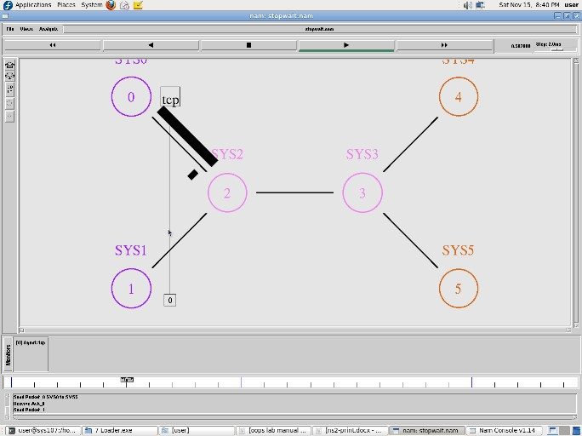

4.0 RESULT

EX.NO:11
DATE: ERROR DETECTION TECHNIQUE- CYCLIC REDUNDANCY CHECK CRC)
1.0 AIM:
To implement the error detection technique cyclic redundancy check.
2.0 ALGORITHM:
- Start the program
- Enter the data and generate the polynomial.
- Call the CRC function with performs XOR between the divisor and generated.
- Display the checksum.
- Once the final code is generated, error detection test can be made.
- Enter the position where error is to be inserted and display the erroneous data.
- Call the CRC and to check the error.
- If the error exists, display “error detected” else “no error detected”.
- Stop the program.
3.0 PROGRAM:
import java.io.*; class crc_gen
{
public static void main(String args[]) throws IOException
{
BufferedReader br=new BufferedReader(new InputStreamReader(System.in)); int[] data; int[] div; int[] divisor; int[] rem; int[] crc;
int data_bits, divisor_bits, tot_length;
System.out.println("Enter number of data bits : "); data_bits=Integer.parseInt(br.readLine()); data=new int[data_bits];
System.out.println("Enter data bits : "); for(int i=0; i<data_bits; i++)
data[i]=Integer.parseInt(br.readLine());
System.out.println("Enter number of bits in divisor : "); divisor_bits=Integer.parseInt(br.readLine()); divisor=new int[divisor_bits];
System.out.println("Enter Divisor bits : "); for(int i=0; i<divisor_bits; i++) divisor[i]=Integer.parseInt(br.readLine()); /* System.out.print("Data bits are : "); for(int i=0; i< data_bits; i++) System.out.print(data[i]); System.out.println();
System.out.print("divisor bits are : "); for(int i=0; i< divisor_bits; i++) System.out.print(divisor[i]);
System.out.println();
*/ tot_length=data_bits+divisor_bits-1; div=new int[tot_length]; rem=new int[tot_length]; crc=new int[tot_length];
/*------------------ CRC GENERATION-----------------------*/
for(int i=0;i<data.length;i++) div[i]=data[i];
System.out.print("Dividend (after appending 0's) are : ");
for(int i=0; i< div.length; i++) System.out.print(div[i]); System.out.println(); for(int j=0; j<div.length; j++){
rem[j] = div[j];
}
rem=divide(div, divisor, rem);
for(int i=0;i<div.length;i++) //append dividend and ramainder
{
crc[i]=(div[i]^rem[i]);
}
System.out.println();
System.out.println("CRC code : "); for(int i=0;i<crc.length;i++)
System.out.print(crc[i]);

/*-------------------ERROR DETECTION---------------------*/
System.out.println();
System.out.println("Enter CRC code of "+tot_length+" bits : ");
for(int i=0; i<crc.length; i++) crc[i]=Integer.parseInt(br.readLine()); /* System.out.print("crc bits are : "); for(int i=0; i< crc.length; i++) System.out.print(crc[i]);
System.out.println();
*/
for(int j=0; j<crc.length; j++){
rem[j] = crc[j];
}
rem=divide(crc, divisor, rem); for(int i=0; i< rem.length; i++) { if(rem[i]!=0)
{
System.out.println("Error");
break;
}
if(i==rem.length-1) System.out.println("No Error");
}
System.out.println("THANK YOU.... :)");
}
static int[] divide(int div[],int divisor[], int rem[])
{ int cur=0;
while(true)
{
for(int i=0;i<divisor.length;i++) rem[cur+i]=(rem[cur+i]^divisor[i]);
while(rem[cur]==0 && cur!=rem.length-1)
cur++;
if((rem.length-cur)<divisor.length) break;
} return rem;
}
}
OUTPUT:
Enter number of data bits : 7
Enter data bits :
1
0
1
1
0
0
1
Enter number of bits in divisor :
3
Enter Divisor bits :
1
0
1
Data bits are : 1011001
divisor bits are : 101
Dividend (after appending 0's) are : 101100100 CRC code : 101100111
Enter CRC code of 9 bits :
1
0
1
1
0
0
1
0 1
crc bits are : 101100101 Error
THANK YOU.... :)
Press any key to continue...

4.0 RESULT

EX NO 12
DATE: APPLICATIONS USING TCP AND UDP SOCKETS LIKE SNMP

1.0 AIM:
To write a java program for simulation of Simple Network management Protocols.

2.0 ALGORITHM:

MANAGER
  - Start the program.
  - Create an unnamed socket for client using socket ( ) system.
  - Call with parameters AF_INET as domain and SOCK_STREAM as type. Step 4: Name the socket using bind ( ) system call.
  - Now connect the socket to agent using connect ( ) system call.
  - Get the input for the type of information needed from the agent.
  - If the input is equal to „TCP connection‟ then goto next Step else If it is equal to „system‟ Goto Step 9.
  - Read the input for the object, send it and receive the details of the TCP connection of that object from the agent. Go to Step 10.
  - Read the input for the object, send it and receive the details of the system from the agent. Go to Step 10.
  - Receive the message, print and terminate the process. Stop the process.

AGENTS
  - Start the program.
  - Create an unnamed socket for the server using the parameters AF_INET as domain and the SOCK_STREAM as type.
  - Name the socket using bind( ) system call with the parameters server_sockfd and the manager address(sin_addr and sin_sport).
  - Create a connection queue and wait for manager using the listen ( ) system call with the number of manager request as parameters.
  - Accept the connection using accept( ) system call when manager requests for connection.
  - Receive the message from the manager. If the request is for „TCP connections‟ then send the details of the requested object, else if the request is for „System‟ then send the details of the requested system.
  - Stop the program execution.

2.0 PROGRAM:
import java.io.IOException; import org.snmp4j.CommunityTarget; import org.snmp4j.PDU;
import org.snmp4j.Snmp; import org.snmp4j.Target; import org.snmp4j.TransportMapping; import org.snmp4j.event.ResponseEvent; import org.snmp4j.mp.SnmpConstants; import org.snmp4j.smi.Address; import org.snmp4j.smi.GenericAddress; import org.snmp4j.smi.OID; import org.snmp4j.smi.OctetString; import org.snmp4j.smi.VariableBinding;
import org.snmp4j.transport.DefaultUdpTransportMapping;
public class SNMPManager {
Snmp snmp = null;
String address = null;
- Constructor * @param
add
*/
public SNMPManager(String add)
{ address = add;
public static void main(String[] args) throws IOException {
/**
- Port 161 is used for Read and Other operations
- Port 162 is used for the trap
generation */
SNMPManager client = new SNMPManager("udp:127.0.0.1/161"); client.start();
/**
- OID - .1.3.6.1.2.1.1.1.0 => SysDec
- OID - .1.3.6.1.2.1.1.5.0 => SysName
- => MIB explorer will be usefull here, as discussed in previous article */
String sysDescr = client.getAsString(new OID(".1.3.6.1.2.1.1.1.0"));
System.out.println(sysDescr);
}
/**
- get any answers because the communication is asynchronous * and the listen() method listens for answers.
- @throws IOException
*/
private void start() throws IOException {
TransportMapping transport = new DefaultUdpTransportMapping(); snmp = new
Snmp(transport); // Do not forget this line!
transport.listen();
}
/**
- Method which takes a single OID and returns the response from the agent as a String.
- @param oid
- @return
- @throws IOException
*/
public String getAsString(OID oid) throws IOException { ResponseEvent event = get(new OID[] { oid });
return event.getResponse().get(0).getVariable().toString();
}
/**
- This method is capable of handling multiple OIDs
- @param oids
- @return
- @throws IOException
*/
public ResponseEvent get(OID oids[]) throws IOException {
PDU pdu = new PDU(); for (OID oid : oids) {
pdu.add(new VariableBinding(oid));
}
pdu.setType(PDU.GET);
ResponseEvent event = snmp.send(pdu, getTarget(), null); if(event != null) { return event;
}
throw new RuntimeException("GET timed out");
}
/**
- This method returns a Target, which contains information about * where the data should be fetched and how.
- @return
*/
private Target getTarget() {
Address targetAddress = GenericAddress.parse(address); CommunityTarget target = new CommunityTarget(); target.setCommunity(new OctetString("public")); target.setAddress(targetAddress);
target.setRetries(2); target.setTimeout(1500);
target.setVersion(SnmpConstants.version2c); return target;
}}

OUTPUT:
Hardware: x86 Family 6 Model 23 Stepping 10 AT/AT COMPATIBLE – Software: Windows 2000 Version 5.1 (Build 2600 Multiprocessor Free)

4.0 RESULT

EX NO : 13
DATE: IMPLEMENTATION OF SUBNETTING

1.0 AIM:
To write a java program to implement subnetting and find the subnet masks.
2.0 ALGORITHM:
- Start the program
- Declare the arguments as Host ip and Netmask
- Calculate subnet-mask
- Print the first address and last address 5. Compile and Run the program
6. Stop the program.

3.0 PROGRAM:
package subnet; import java.util.Scanner; import java.io.*; import java.net.*; public class Subnet {
public static void main(String[] args)
{
Scanner sc = new Scanner(System.in);
System.out.println("Enter the ip address");
String ip = sc.nextLine(); String split_ip[]=ip.split("\\."); //SPlit the string after every .
String split_bip[] = new String[4];
//split binary ip String bip=""; for(int i=0;i<4;i++){
split_bip[i] = appendZeros(Integer.toBinaryString(Integer.parseInt(split_ip[i])));
// “18” => 18 => 10010=>00010010
bip += split_bip[i];
}
System.out.println("IP in binary is" +bip);
System.out.println("Enter the number of addresses:"); int n = sc.nextInt(); //Calculation of mask
int bits = (int)Math.ceil(Math.log(n)/Math.log(2));
/*eg if address = 120, log 120/log 2 gives log to the base 2 => 6.9068, ceil gives us upper integer */
System.out.println("Number of bits required for address=" +bits); int mask = 32-bits;
System.out.println("The subnet mask is="+mask); //Calculation of first address and last address int fbip[]= new int[32]; for(int i=0; i<32;i++)
fbip[i] = (int)bip.charAt(i)-48;

//convert character 0,1 to integer 0,1 for(int i=31;i>31-bits;i--)
//Get first address by ANDing last n bits with 0 fbip[i] &= 0; String fip[]={"","","",""}; for(int i=0;i<32;i++) fip[i/8] = new String (fip[i/8] + fbip[i]); System.out.print("First address is = "); for(int i=0;i<4;i++)
{
System.out.print(Integer.parseInt(fip[i],2));
if(i!=3) System.out.print(".");
}
System.out.println(); int lbip[] = new int[32]; for(int i=0; i<32;i++) lbip[i] = (int)bip.charAt(i)-48; //convert cahracter 0,1 to integer 0,1 for(int i=31;i>31-bits;i--) //Get last address by ORing last n bits with 1
lbip[i] |= 1; String lip[] ={"","","",""}; for(int i=0;i<32;i++) lip[i/8] = new String(lip[i/8]+lbip[i]); System.out.print("Last address is ="); for(int i=0;i<4;i++){
System.out.print(Integer.parseInt(lip[i],2));
if(i!=3) System.out.print(".");
}
System.out.println();
}
static String appendZeros(String s){ String temp= "00000000"; return temp.substring(s.length())+ s;
}
}

4.0 OUTPUT:
Enter the ip address
128.56.25.6
IP in binary is10000000001110000001100100000110 Enter the number of addresses: 5
Number of bits required for address=3
The subnet mask is=29
First address is = 128.56.25.0
Last address is =128.56.25.7

5.0 RESULT

EX NO : 14
DATE: STAR TOPOLOGY

1.0 AIM:
To Construct Star Topology

3.0 ALGORITHM

- The aim is to create the topology.
- To perform the experiment, follow the below steps
- A blank square area would be given which defines the working area
- A series of components would be given
- In order to build a topology first select on the component and then immediately click on the working area to place it.
- To draw a line between two components first select the line click on the port of first component and then immediately click on the port of second component
- Once the topology is build then click on the Submit button to test whether the give topology is built correctly or not.

3.0 PROGRAM

#Create a simulator object
set ns [new Simulator]

#Open the nam trace file set nf [open out.nam w]
$ns namtrace-all $nf

#Define a 'finish' procedure

proc finish {} { global ns nf $ns flush-trace #Close the trace file close $nf

#Executenam on the trace file exec nam out.nam & exit0

}

#Create six nodes set n0 [$ns node] set n1 [$ns node] set n2 [$ns node] set n3 [$ns node] set n4 [$ns node] set n5 [$ns node]

#Change the shape of center node in a star topology
$n0 shape square
#Create links between the nodes
$ns duplex-link $n0 $n1 1Mb 10ms DropTail
$ns duplex-link $n0 $n2 1Mb 10ms DropTail
$ns duplex-link $n0 $n3 1Mb 10ms DropTail
$ns duplex-link $n0 $n4 1Mb 10ms DropTail
$ns duplex-link $n0 $n5 1Mb 10ms DropTail

#Create a TCP agent and attach it to node n0 set tcp0 [new Agent/TCP] $tcp0 set class_ 1
$ns attach-agent $n1 $tcp0

#Create a TCP Sink agent (a traffic sink) for TCP and attach it to node n3
set sink0 [new Agent/TCPSink]
$ns attach-agent $n3 $sink0
#Connect the traffic sources with the traffic sink
$ns connect $tcp0 $sink0
# Create a CBR traffic source and attach it to tcp0 set cbr0 [new Application/Traffic/CBR]
$cbr0 set packetSize_ 500
$cbr0 set interval_ 0.01
$cbr0 attach-agent $tcp0
#Schedule events for the CBR agents
$ns at 0.5 "$cbr0 start"
$ns at 4.5 "$cbr0 stop"
#Call the finish procedure after 5 seconds of simulation time
$ns at 5.0 "finish"
#Run the simulation
$ns run

4.0 RESULT

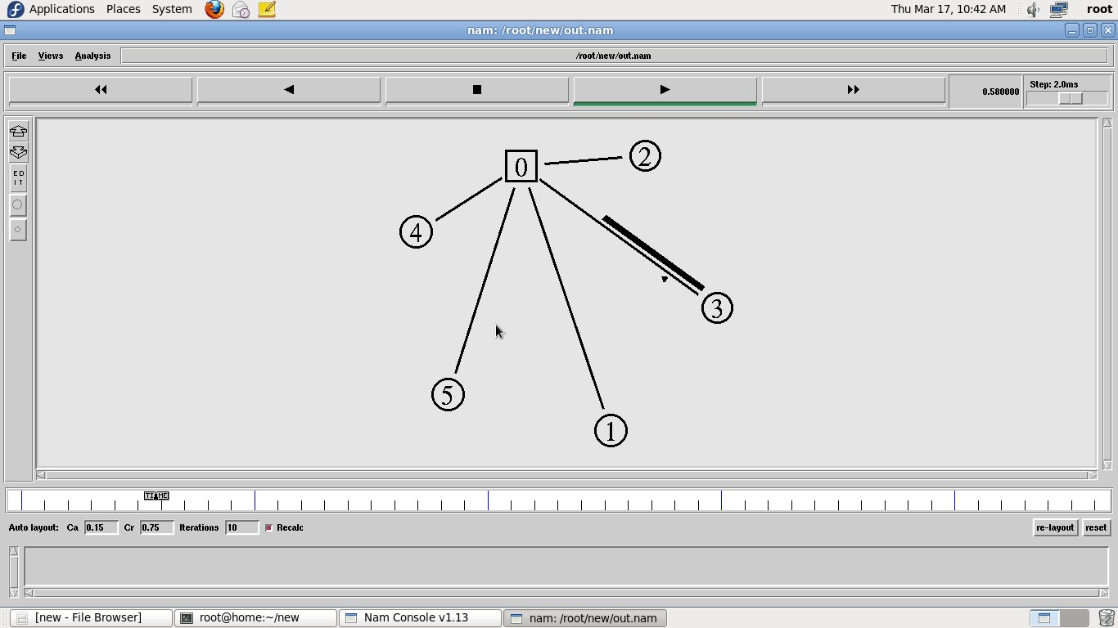

5.0 RESULT

EX NO : 15
DATE: RING TOPOLOGY

1.0 AIM:
To Construct RingTopology

2.0 ALGORITHM
- Create a simulator object
- Define different colors for different data flows
- Open a nam trace file and define finish procedure then close the trace file, and execute nam on trace file.
- Create five nodes that forms a network numbered from 0 to 4 5. Create duplex links between the nodes to form a Ring Topology.
- Setup TCP Connection between n(1) and n(3)
- Apply CBR Traffic over TCP
- Schedule events and run the program.

3.0 PROGRAM

#Create a simulator object set ns [new Simulator] #Open the nam trace file set nf [open out.nam w]
$ns namtrace-all $nf

#Define a 'finish' procedure proc finish {} { global ns nf $ns flush-trace #Close the trace file close $nf
#Executenam on the trace file
exec nam out.nam & exit0
}
#Create five nodes set n0 [$ns node] set n1 [$ns node] set n2 [$ns node] set n3 [$ns node] set n4 [$ns node] set n5 [$ns node]

#Create links between the nodes
$ns duplex-link $n0 $n1 1Mb 10ms DropTail
$ns duplex-link $n1 $n2 1Mb 10ms DropTail
$ns duplex-link $n2 $n3 1Mb 10ms DropTail
$ns duplex-link $n3 $n4 1Mb 10ms DropTail
$ns duplex-link $n4 $n5 1Mb 10ms DropTail
$ns duplex-link $n5 $n0 1Mb 10ms DropTail

#Create a TCP agent and attach it to node n0 set tcp0 [new Agent/TCP] $tcp0 set class_ 1
$ns attach-agent $n1 $tcp0
#Create a TCP Sink agent (a traffic sink) for TCP and attach it to node n3 set sink0 [new Agent/TCPSink]
$ns attach-agent $n3 $sink0
#Connect the traffic sources with the traffic sink
$ns connect $tcp0 $sink0

# Create a CBR traffic source and attach it to tcp0 set cbr0 [new Application/Traffic/CBR]
$cbr0 set packetSize_ 500
$cbr0 set interval_ 0.01
$cbr0 attach-agent $tcp0

#Schedule events for the CBR agents
$ns at 0.5 "$cbr0 start"
$ns at 4.5 "$cbr0 stop"

#Call the finish procedure after 5 seconds of simulation time
$ns at 5.0 "finish"
#Run the simulation $ns run

4.0 OUTPUT

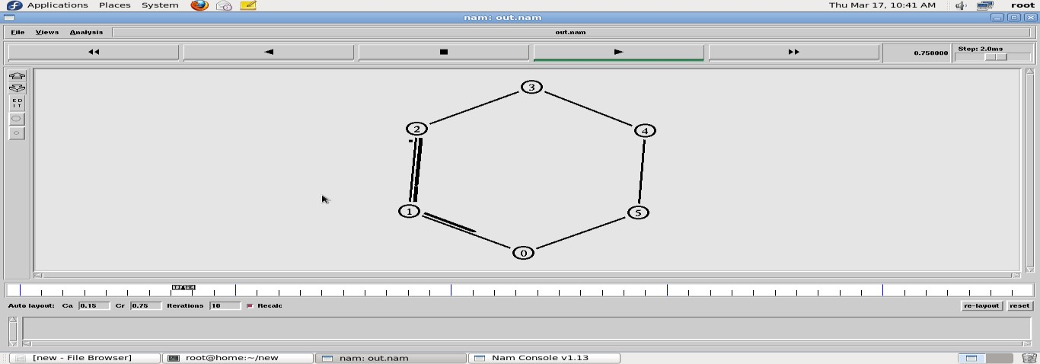

5.0 RESULT

EX NO: 16
DATE: CASE STUDY- LAN ENVIRONMENT IN LAB

AIM: To carry out a study regarding LAN configuration inside the lab

Find out information about the network in your lab and fill in details below:

- Total Number of computers in your lab:
- Find details of any 5 computers:

 | MAC address | IP address | LAN speed | Default mask | hostname
1
2
3
4
5

- Are the IP addresses assigned to the machines statically or dynamically?

- Does the network have a DHCP server?

- If yes, what is the address of the server?

- How many servers are configured?

 | DETAILS OF THE SERVER
 | IP address | MAC address | Purpose
1
2
3

- Cables
    - Type:
    - Is it coaxial / twisted pair or fiber optic cable?
    - Cable bandwidth iv. Maximum cable length limit
v. Connector used
- Details of Switches

No | Company Name | MAC address | No. of ports | Managed / Unmanaged | IP’s of  Machines connected to the switch
1
2
3
4
5
- Details of Routers

No | Company Name | No. / Types of ports | Port speed | IP address
1
2
3

- Is there Wi-Fi capability in the LAN?

If yes,
  - What is the Wi-Fi access point address?

  - How many devices / IP addresses does it support?

  - What is the bandwidth?

If no,

  - What will be its IP address?

  - What additional devices are needed?

- Is there internet access in the lab?
If not, what changes to the hardware / software must be made? If yes, what is the IP address of the router / gateway?

- Draw the Network Topology (show how machines and servers are connected using connectivity devices)

RESULT

